**Banking System**

**Task 1:**

(Screenshots are attached with Task 2)

Create database HMBank

1. Creating Customers Table:

Create table customers(

Customer_id int primary key,

First_name varchar(20) not null,

Last_name varchar(20),

DOB date,

Email varchar(40) not null,

Phone_number varchar(15) not null,

Address varchar(100)

)

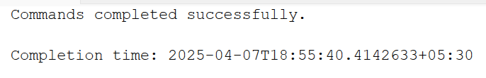

1. Create table accounts

Create table accounts(

Account_id int primary key,

Customer_id int,

Account_type varchar(20),

Balance int,

Foreign key(customer_id) references customers(customer_id)

)



1. Create table Transactions

Create table transactions(

Transaction_id int primary key,

Account_id int,

Transaction_type varchar(20),

Amount int,

Transaction_date date,

Foreign key(account_id) references accounts(account_id)

)



Entity Relationship Diagram :

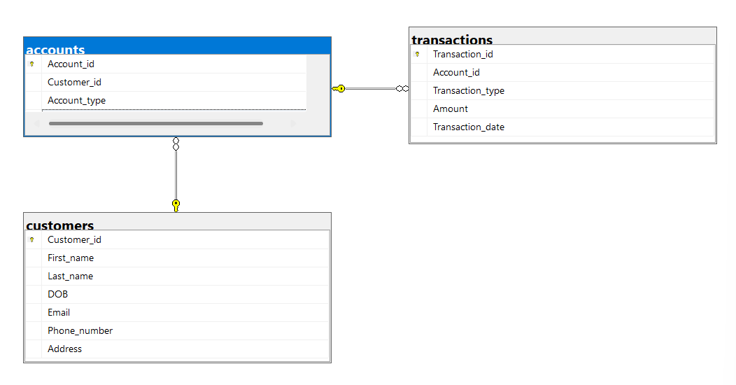

**Task 2:**

**1)Inserting into Customers Table:**

INSERT INTO customers VALUES (1001, 'Aakash', 'Gupta', '2003-11-29', 'aakash@gmail.com', 987654321, '21, new street, ramapuram, chennai');

INSERT INTO customers VALUES (1002, 'sai', 'riteshvar', '2003-03-30', 'sai@gmail.com', 9878363728, '10, andavar nagar, villivakkam, Chennai');

INSERT INTO customers VALUES (1003, 'varshini', 'sankar', '2004-08-24', 'varshini@gmail.com', 6373828288, '23, church street, Bangalore');

INSERT INTO customers VALUES (1004, 'Priyanka', 'Mohan', '2003-10-25', 'priyankamohan@gmail.com', 8972627828, '2, st thomas mount, Chennai');

INSERT INTO customers VALUES (1005, 'Maya', 'Krishnan', '2004-12-04', 'mayakrishnan@gmail.com', 7894523567, '21, royapettah, Chennai');

INSERT INTO customers VALUES (1006, 'Abishek', 'Nirmal', '2002-08-07', 'abisheknirmal@gmail.com', 9872527167, '23, Krishna Street, Royapuram, Chennai');

INSERT INTO customers VALUES (1007, 'Vishwa', 'Vajendra', '2003-10-09', 'vishwavajendra@gmail.com', 9282982873, '12, Maya street, anna nagar, Chennai');

INSERT INTO customers VALUES (1008, 'Haniya', 'Hameed', '2004-06-11', 'haniyahameed@gmail.com', 9282782292, '16, mark antony street, besant bagar, Chennai');

INSERT INTO customers VALUES (1009, 'Viyanna', 'Koul', '2001-05-23', 'viyannakoul@gmail.com', 9832738383, '9, kumbakonam street, Chennai');

INSERT INTO customers VALUES (1010, 'Miyanna', 'Nigar', '2004-06-11', 'miyannanigar@gmail.com', 7282973897, '8, old street, T nagar, Chennai');

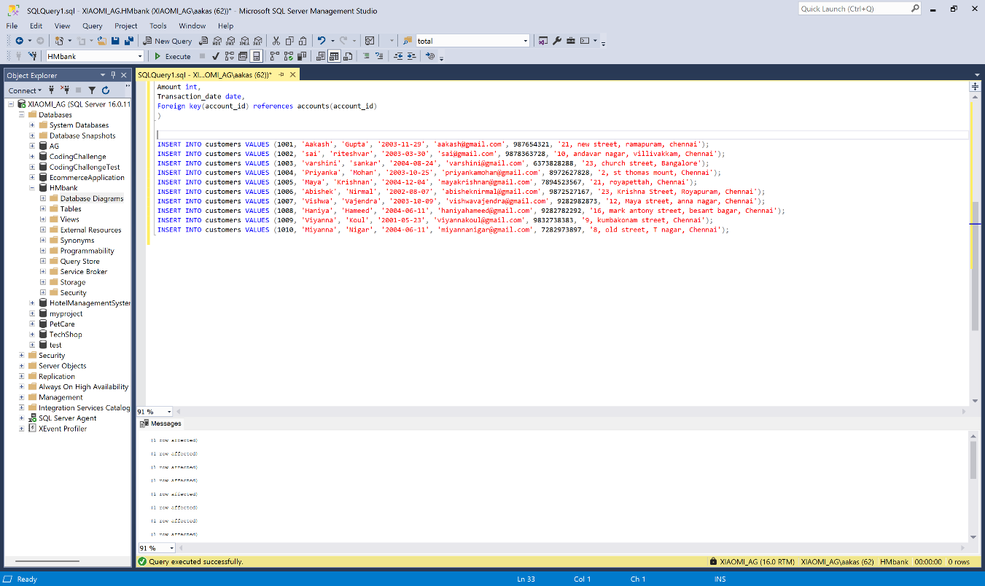

**Inserting into Accounts Table:**

INSERT INTO accounts VALUES (1230, 1001, 'savings', 20000);

INSERT INTO accounts VALUES (1231, 1002, 'zero_balance', 25000);

INSERT INTO accounts VALUES (1232, 1003, 'current', 30000);

INSERT INTO accounts VALUES (1233, 1004, 'savings', 35000);

INSERT INTO accounts VALUES (1234, 1005, 'zero_balance', 15000);

INSERT INTO accounts VALUES (1235, 1006, 'current', 40000);

INSERT INTO accounts VALUES (1236, 1007, 'savings', 45000);

INSERT INTO accounts VALUES (1237, 1008, 'zero_balance', 42500);

INSERT INTO accounts VALUES (1238, 1009, 'savings', 33000);

INSERT INTO accounts VALUES (1239, 1010, 'current', 37500);

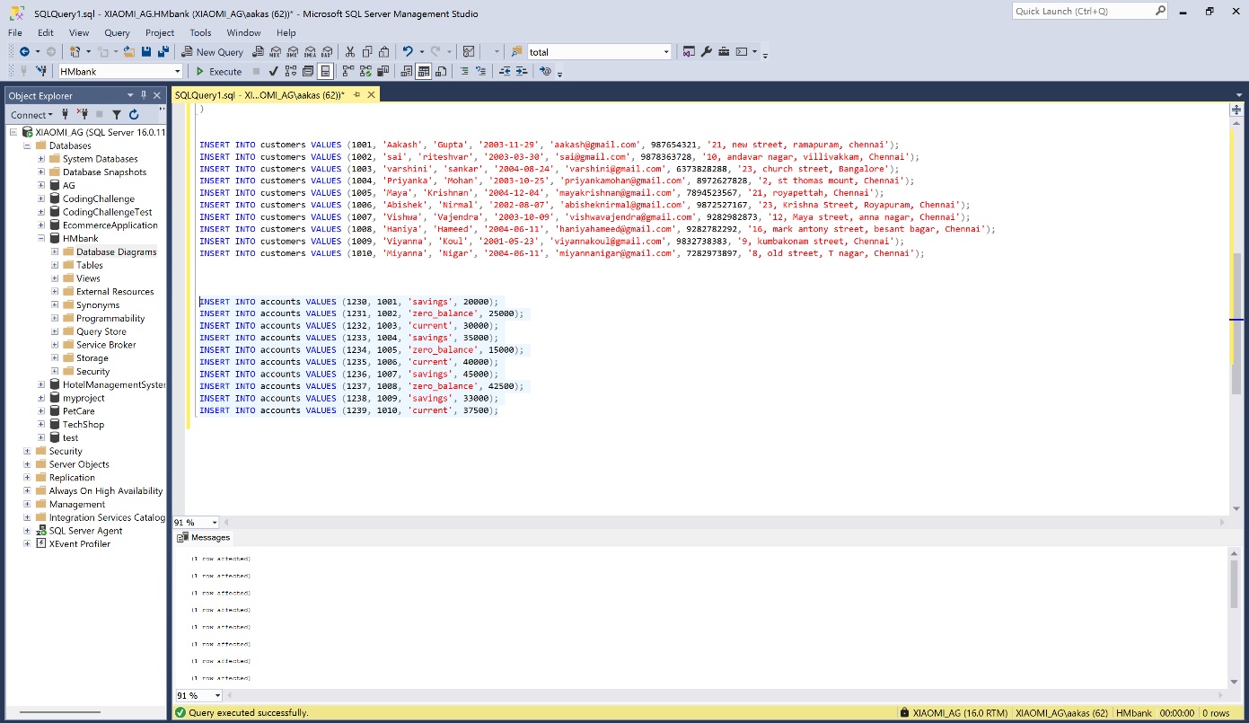

**Inserting into Transactions Table:**

INSERT INTO transactions VALUES (0034, 1230, 'deposit', 20000, '2025-03-16');

INSERT INTO transactions VALUES (0035, 1231, 'withdrawal', 15000, '2025-02-12');

INSERT INTO transactions VALUES (0036, 1232, 'transfer', 5000, '2025-01-13');

INSERT INTO transactions VALUES (0037, 1233, 'transfer', 2500, '2025-02-25');

INSERT INTO transactions VALUES (0038, 1234, 'withdrawal', 1500, '2025-01-20');

INSERT INTO transactions VALUES (0039, 1235, 'deposit', 20000, '2025-03-01');

INSERT INTO transactions VALUES (0040, 1236, 'withdrawal', 4000, '2025-03-03');

INSERT INTO transactions VALUES (0041, 1237, 'deposit', 3500, '2025-02-18');

INSERT INTO transactions VALUES (0042, 1238, 'withdrawal', 500, '2025-01-29');

INSERT INTO transactions VALUES (0043, 1239, 'deposit', 15000, '2025-02-28');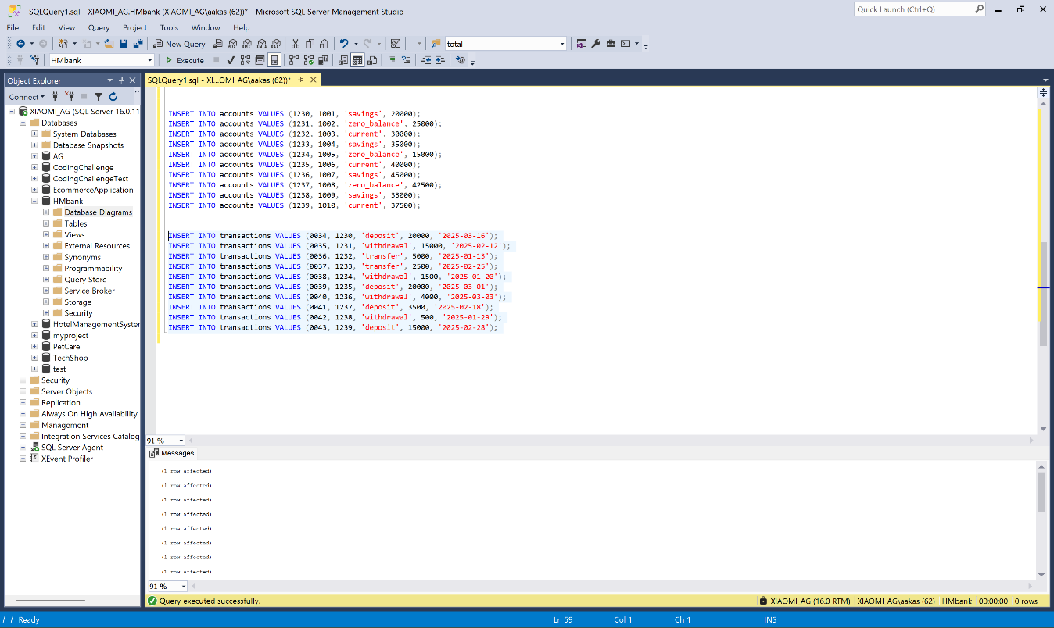

2)SQL Queries

1) select c.first_name, c.last_name, a.account_type, c.email

From customers c inner join accounts a

on c.customer_id = a.customer_id

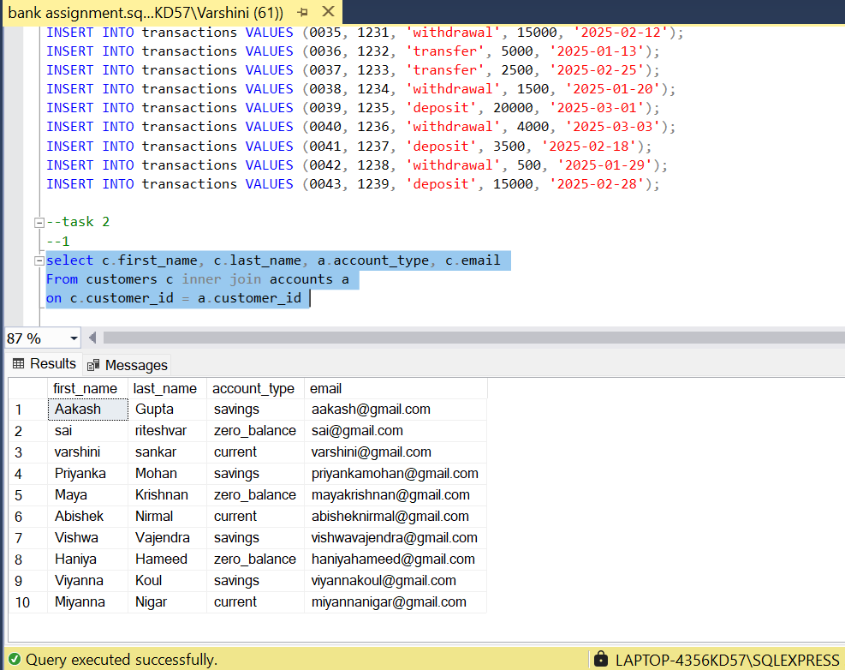

2) select * from transactions

Where account_id in (select account_id from accounts where customer_id=1002)

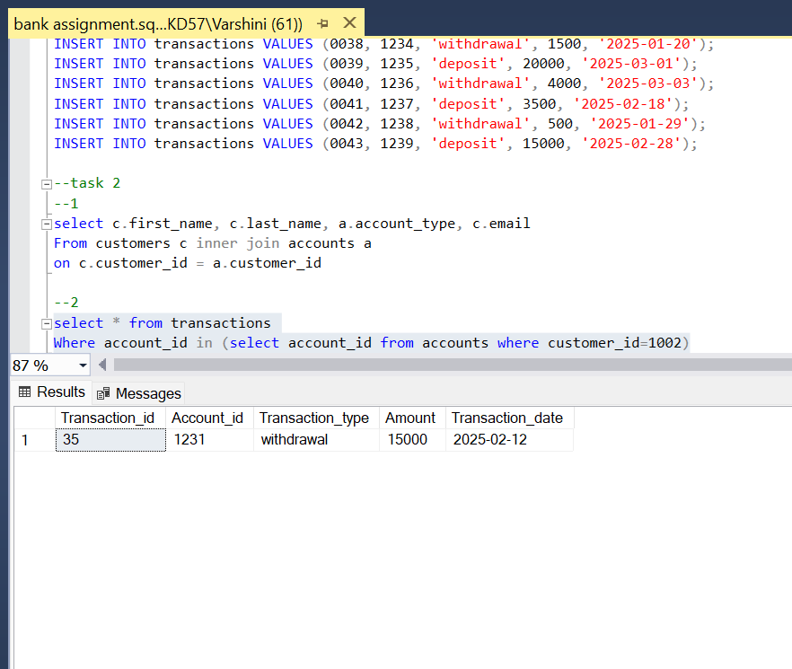

3) update accounts

Set balance=25000

Where account_id=1238

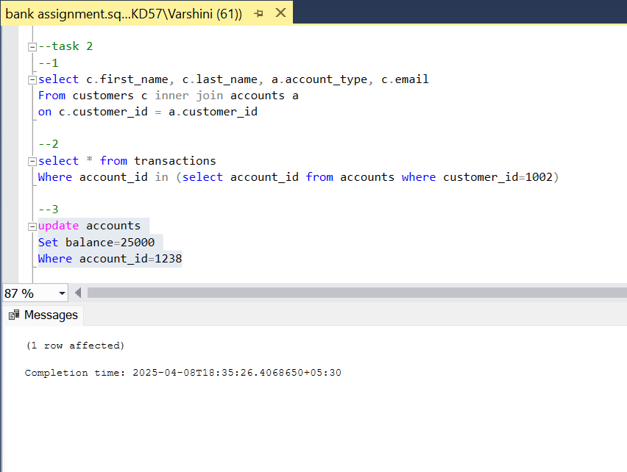

4)select first_name + ‘ ‘ + last_name as ‘full_name’

From customers

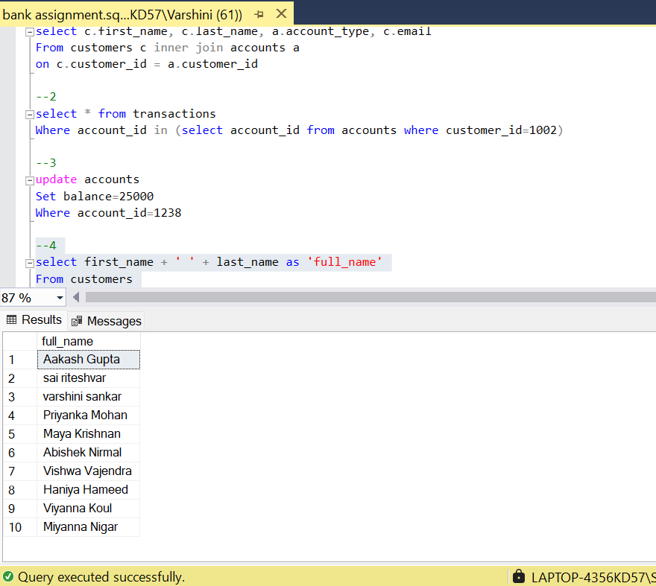

5)delete from accounts

Where balance=0 and account_type=’savings’

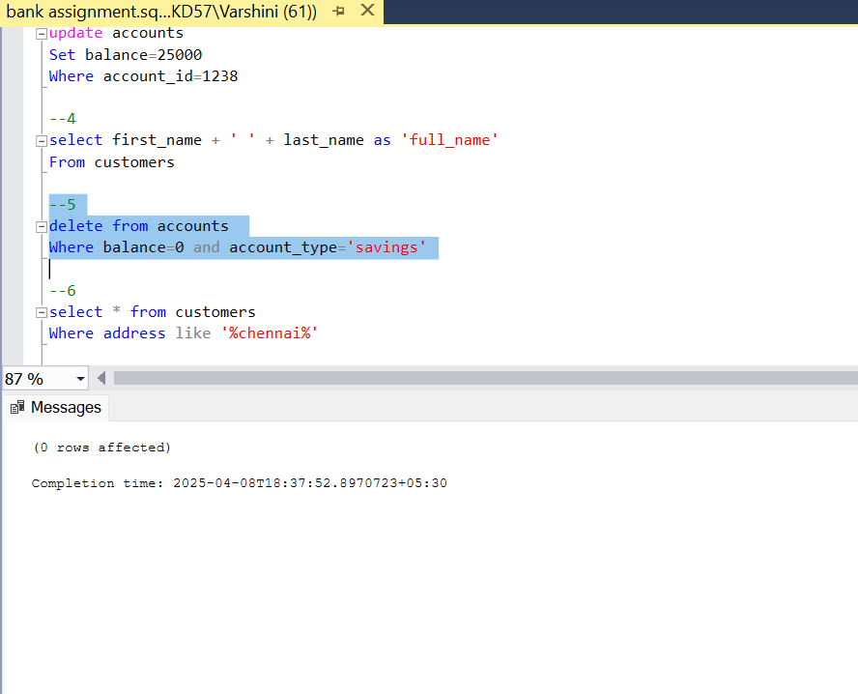

6)select * from customers

Where address like ‘%chennai%’

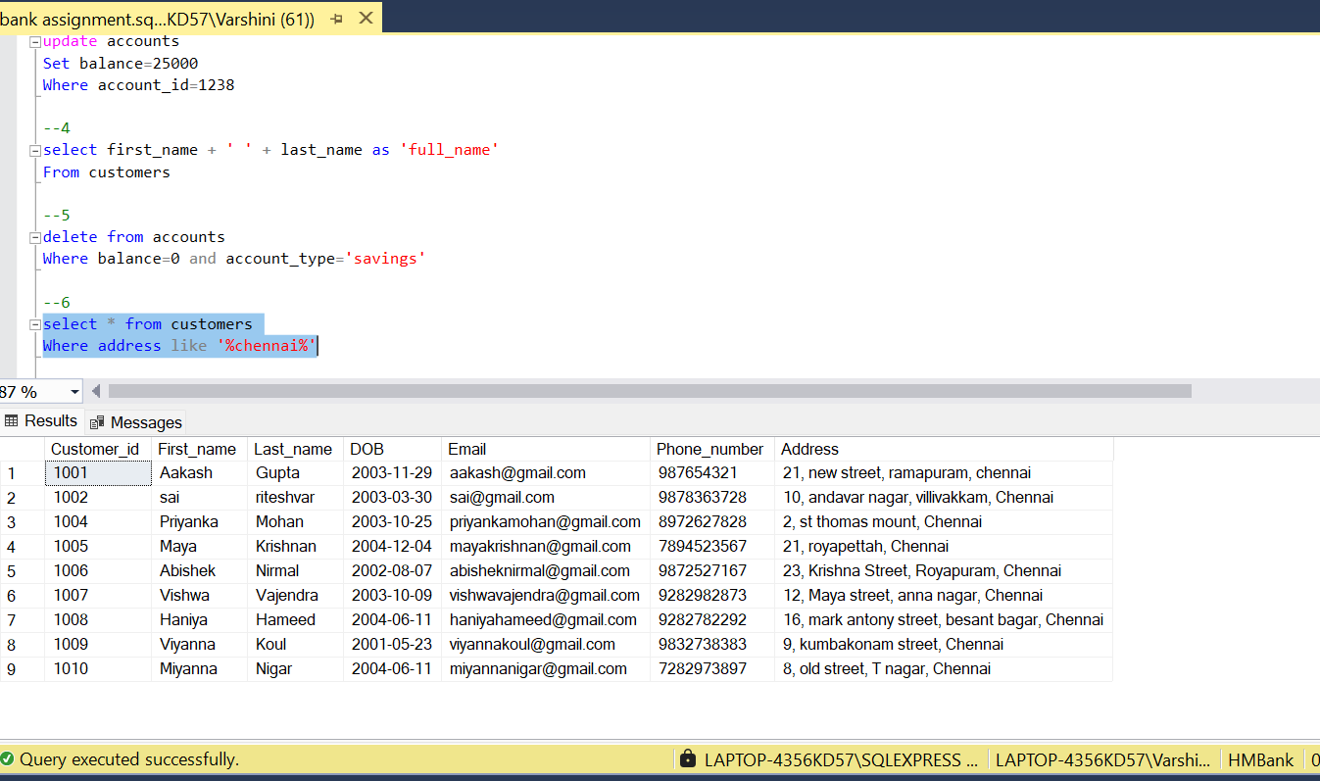

7)select balance from accounts

Where account_id=1234

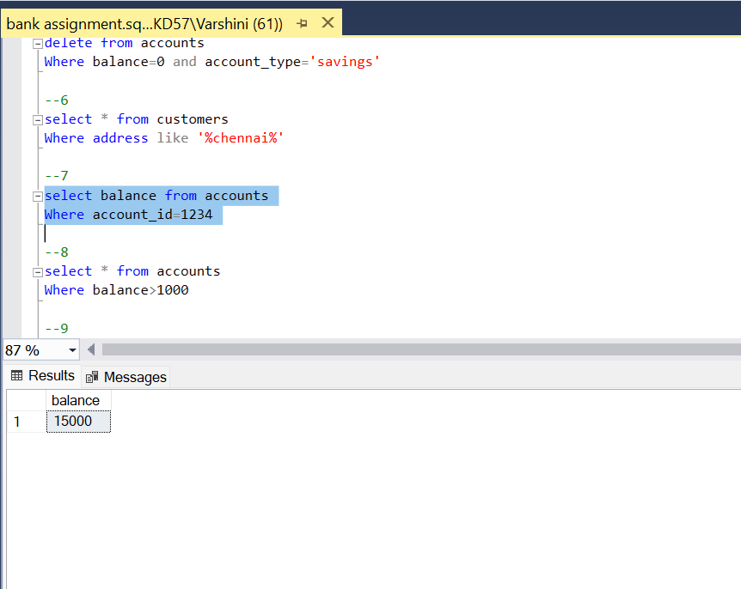

8)select * from accounts

Where balance>1000

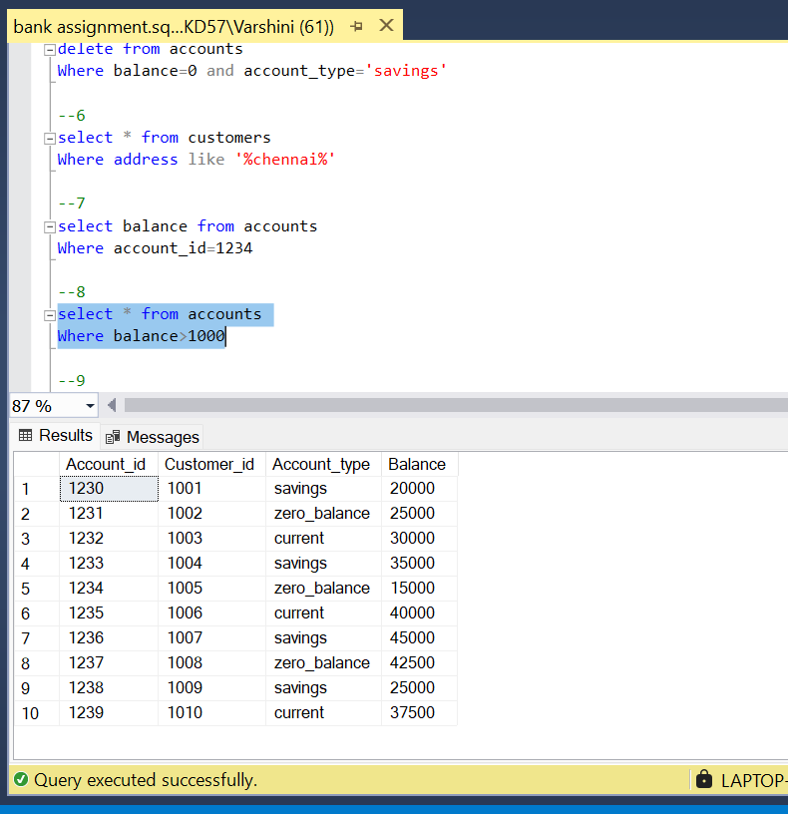

9) select *

From transactions

Where account_id = 1232

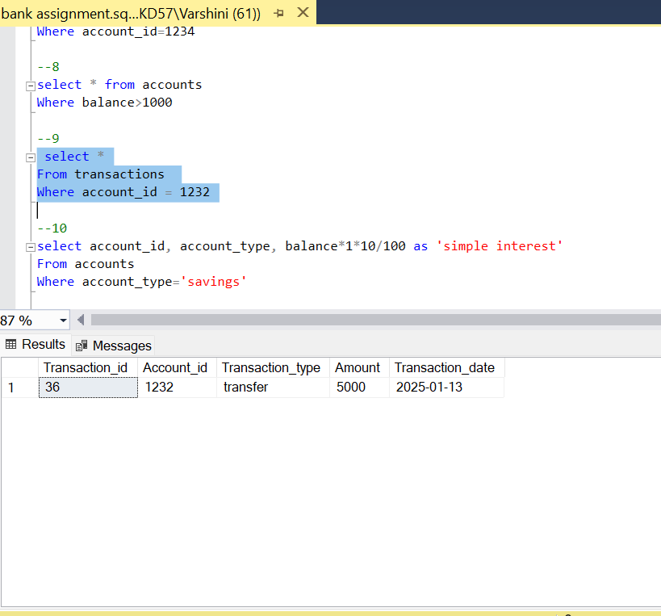

10) select account_id, account_type, balance*1*10/100 as ‘simple interest’

From accounts

Where account_type=’savings’

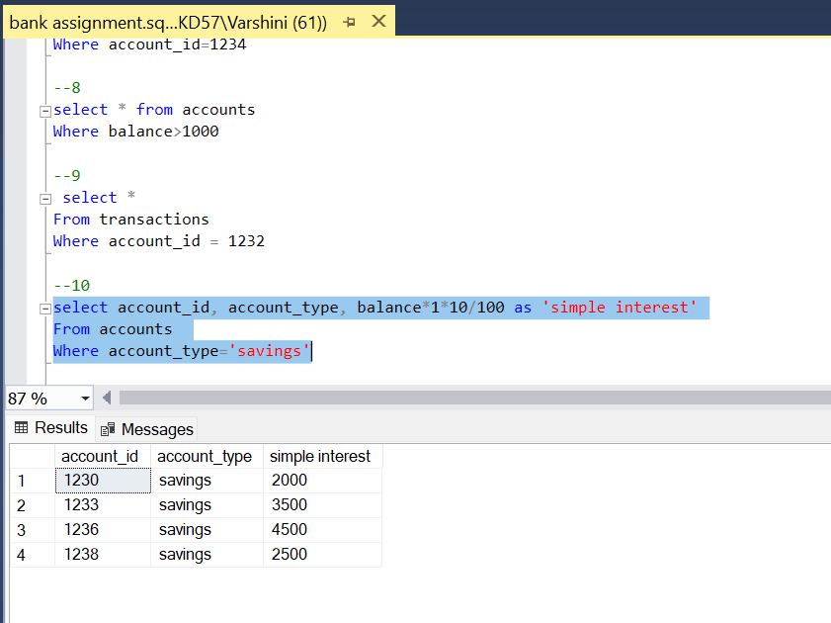

11) select * from accounts

Where balance<20000

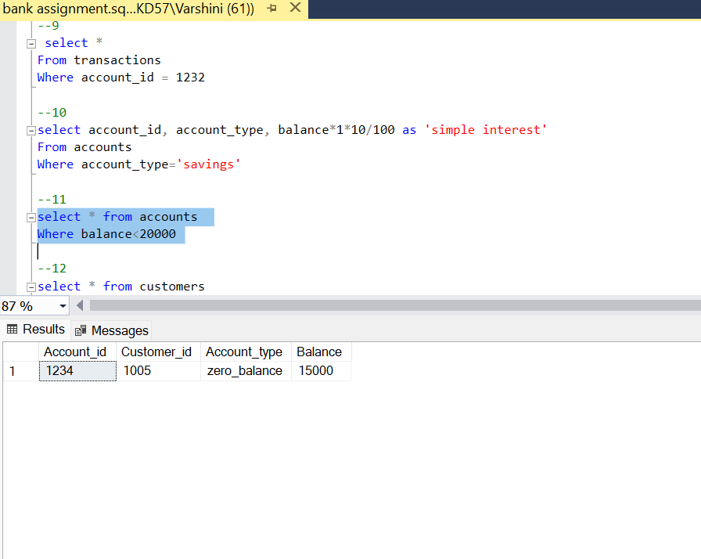

12) select * from customers

Where address not like ‘%chennai%’

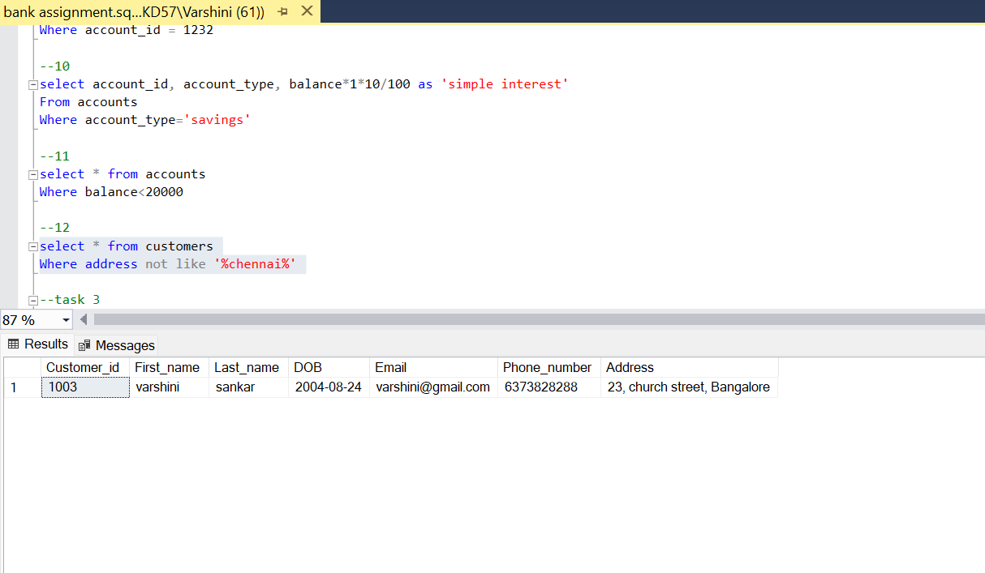

**Task 3:**

1)select avg(balance) ‘average balance’ from accounts

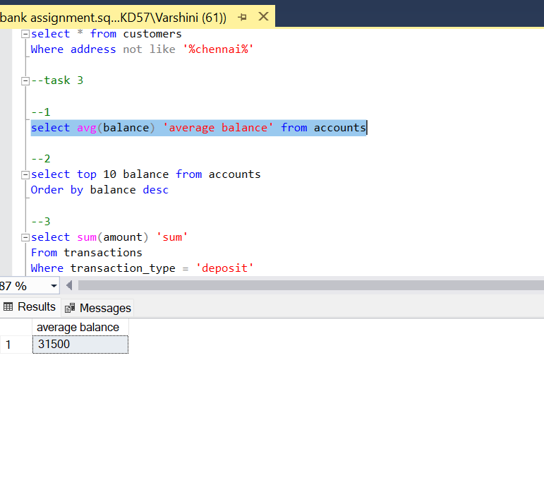

2)select top 10 balance from accounts

Order by balance desc

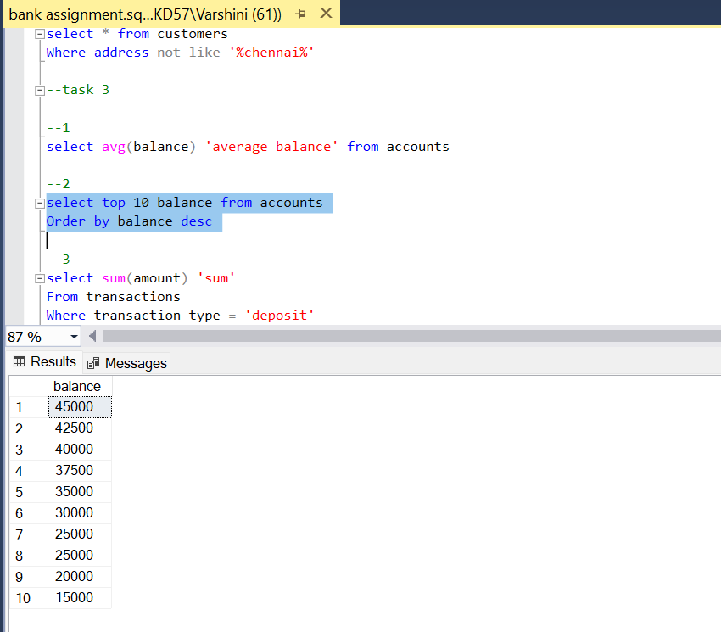

3) select sum(amount) 'sum'

From transactions

Where transaction_type = 'deposit' And Transaction_date = '2025-3-16'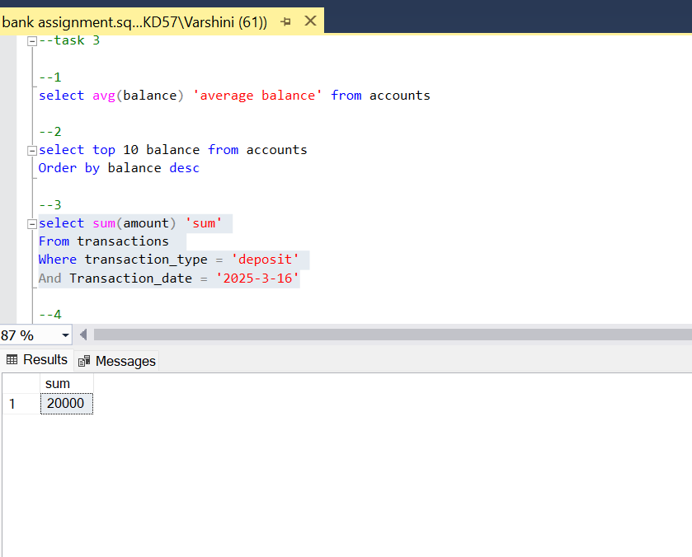

4)select top 1 * from customers

Order by DOB desc

Select top 1 * from customers

Order by DOB asc

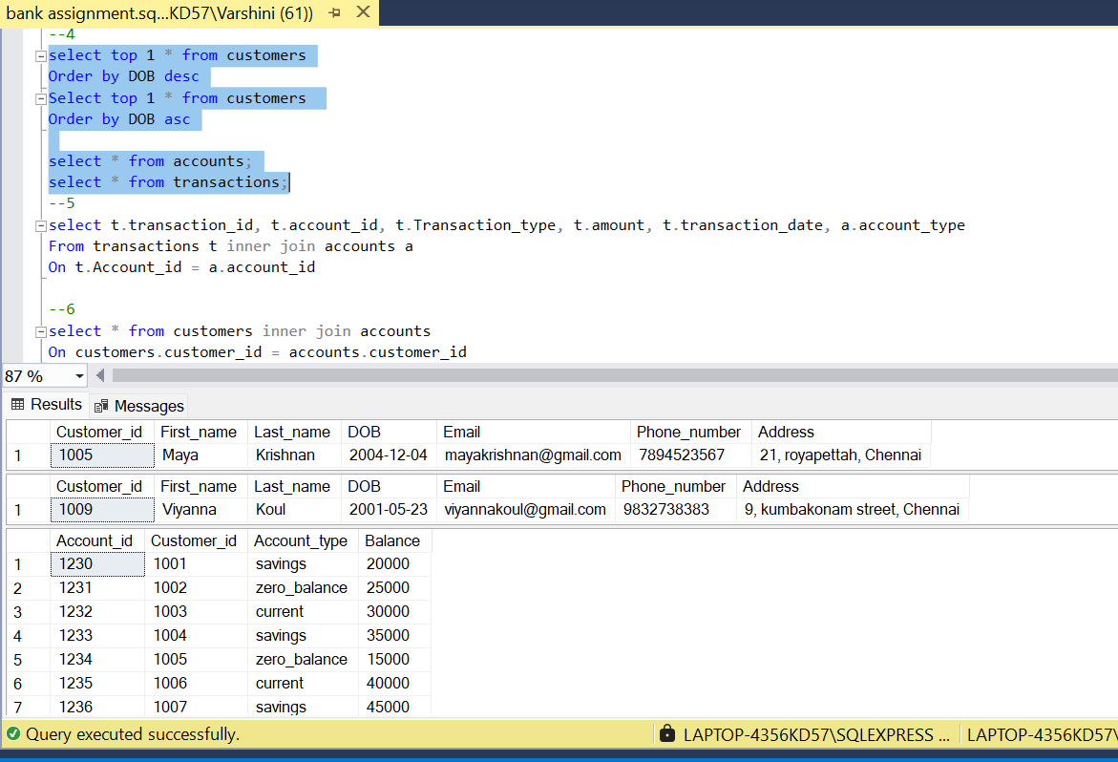

5) select t.transaction_id, t.account_id, t.trasaction_type, t.amount, t.transaction_date, a.account_type

From transactions t inner join accounts a

On t.transaction_id = a.account_id

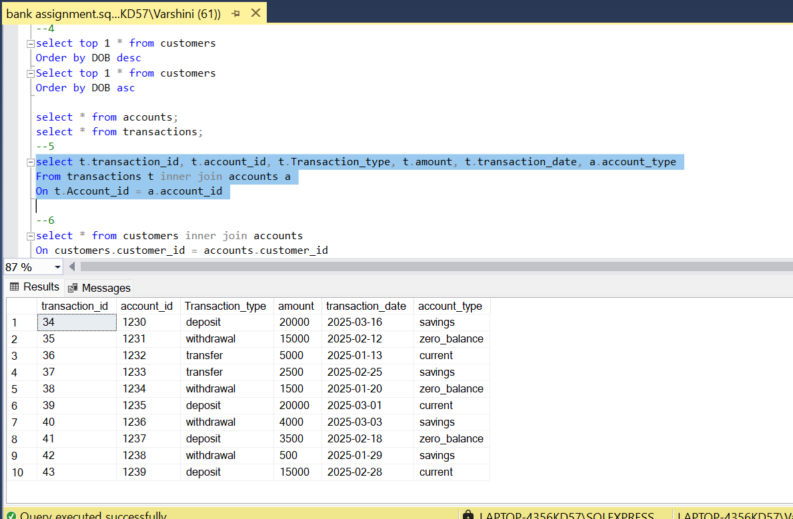

6) select * from customers inner join accounts

On customers.customer_id = accounts.customer_id

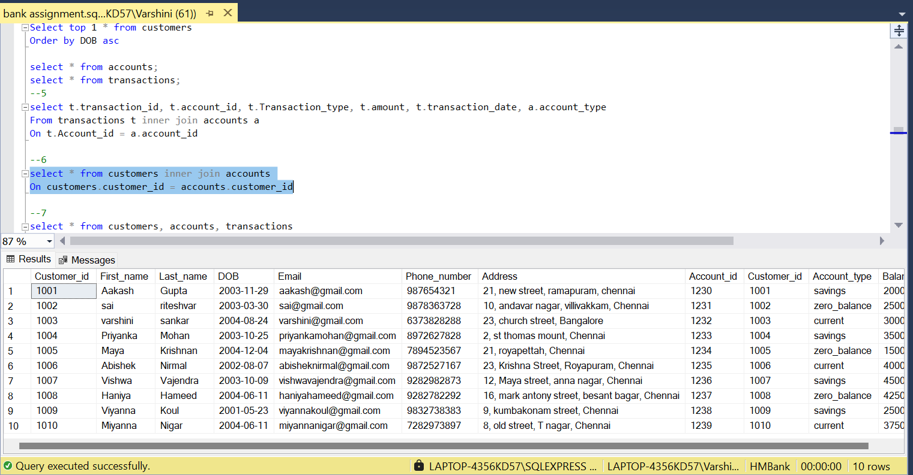

7) select * from customers, accounts, transactions

Where customers.customer_id=accounts.customer_id

And accounts.account_id = transactions.account_id

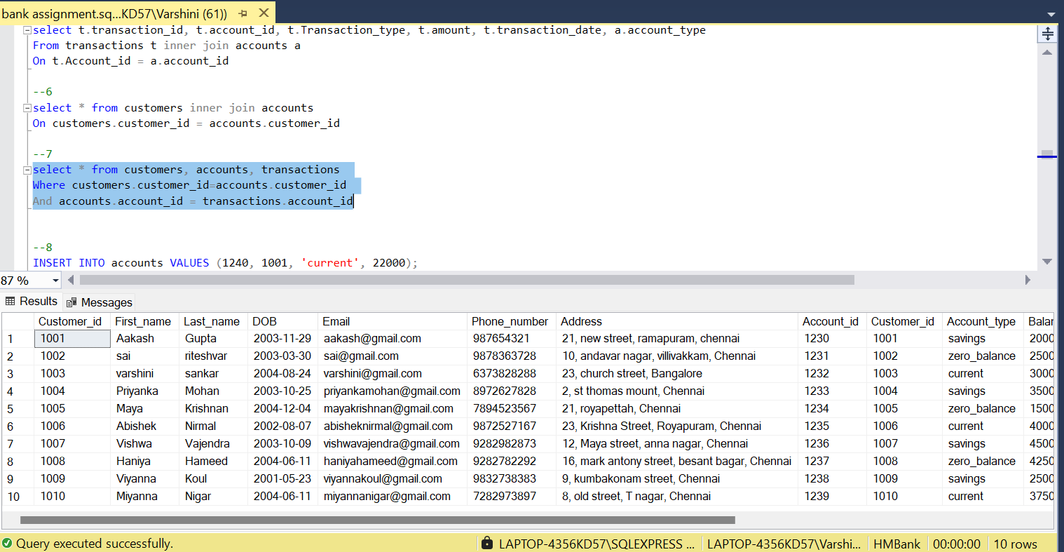

8) select c.customer_id

From customers c inner join accounts a

On c.customer_id = a.customer_id

Group by c.customer_id

Having count(*)>1

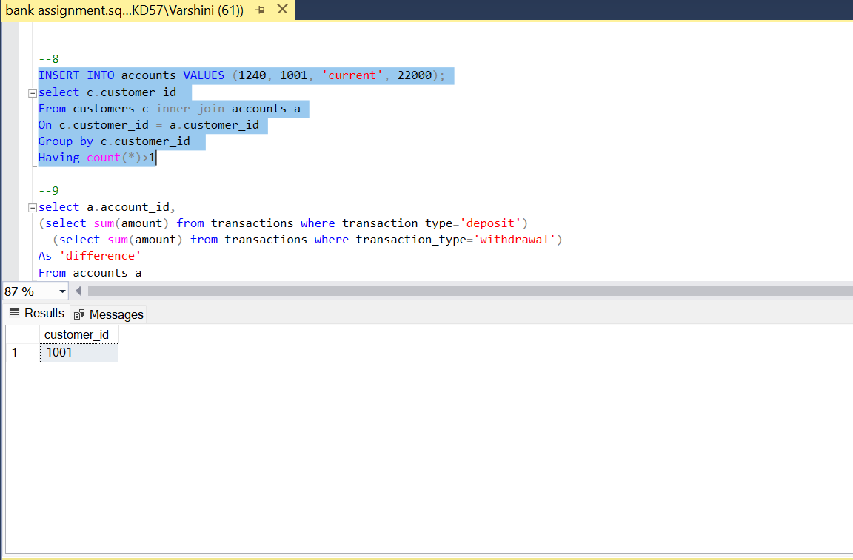

9) select a.account_id,

(select sum(amount) from transactions where transaction_type=’deposit’)

- (select sum(amount) from transactions where transaction_type=’withdrawal’)

As ‘difference’

From accounts a

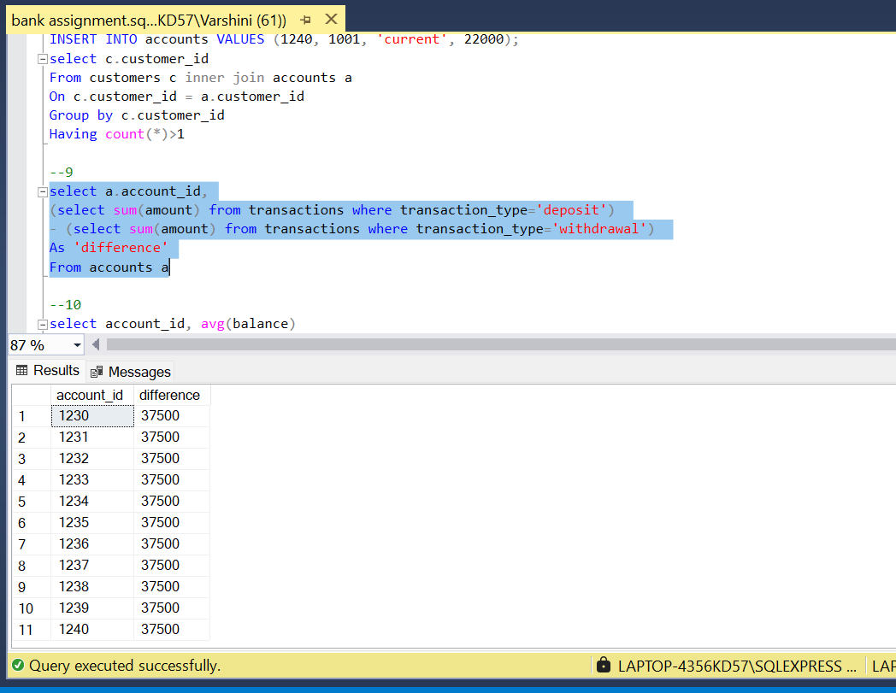

10) select account_id, avg(balance)

From accounts

Where account_id in

(select distinct account_id

From transactions

Where transactions between ‘2025-01-01’ and ‘2025-02-01’)

Group by account_id

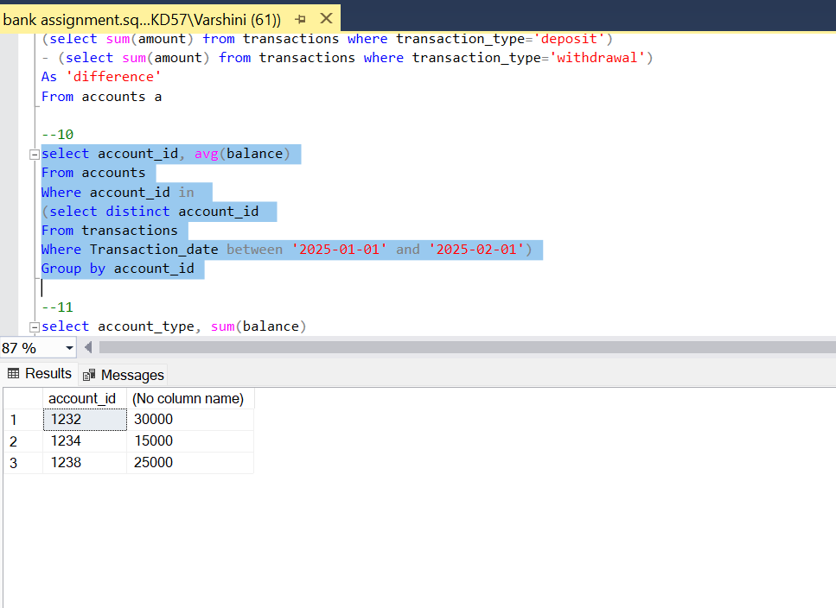

11) select account_type, sum(balance)

From accounts

Group by account_type

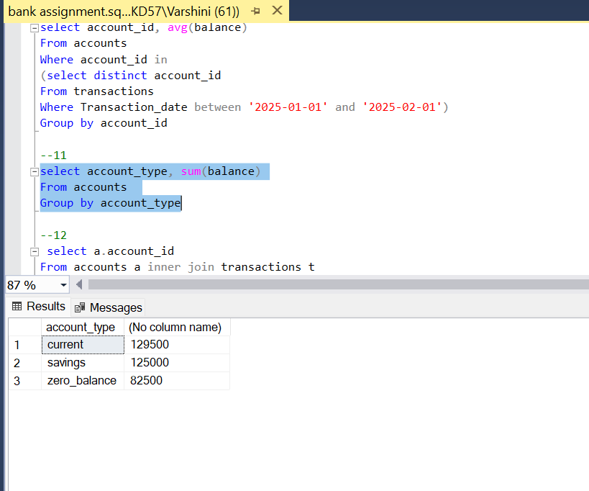

12) select a.account_id

From accounts a inner join transactions t

On a.account_id = t.account_id

Group by a.account_id

Order by count(t.transaction_id) desc

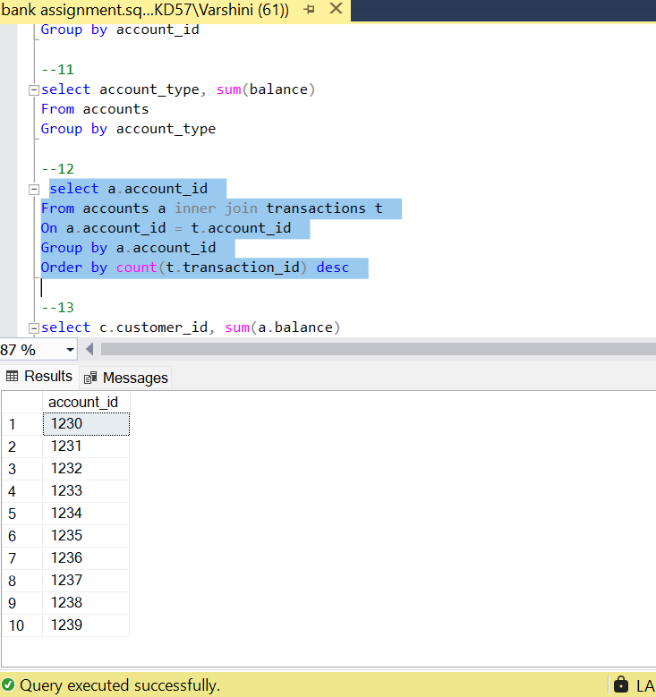

13) select c.customer_id, sum(a.balance)

From customers c inner join accounts a

On c.customer_id=a.customer_id

Group by c.customer_id

Order by sum(a.balance) desc

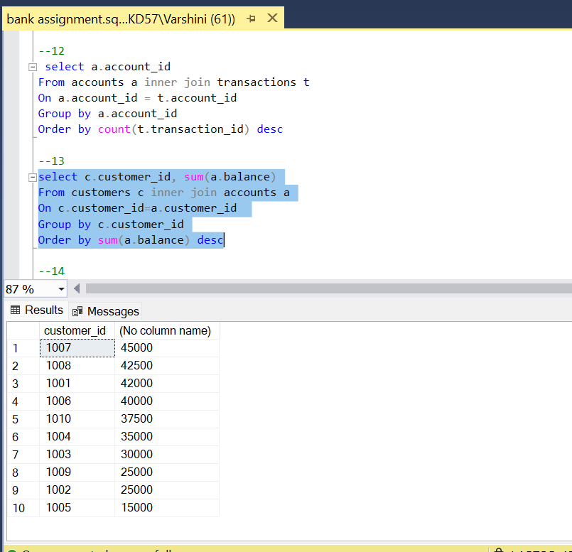

14) SELECT t.*

FROM transactions t

JOIN (

SELECT account_id, amount, transaction_date

FROM transactions

GROUP BY account_id, amount, transaction_date

HAVING COUNT(*) > 1

) dup

ON t.account_id = dup.account_id

AND t.amount = dup.amount

AND t.transaction_date = dup.transaction_date;

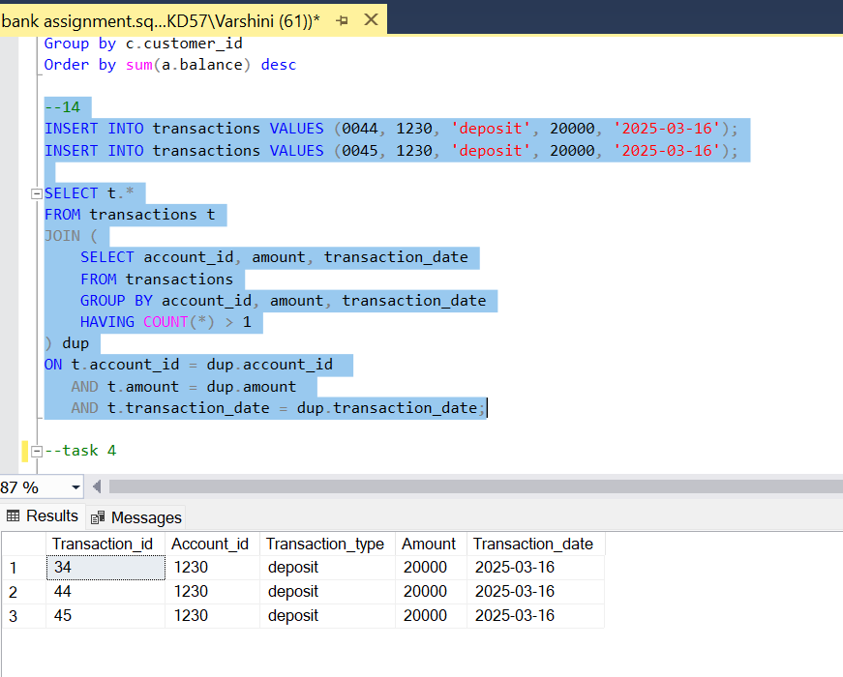

**Task 4:**

1)select c.customer_id, c.first_name, c.last_name, a.balance

From customers c inner join accounts a

On c.customer_id=a.customer_id

Where a.balance=(select max(balance) from accounts)

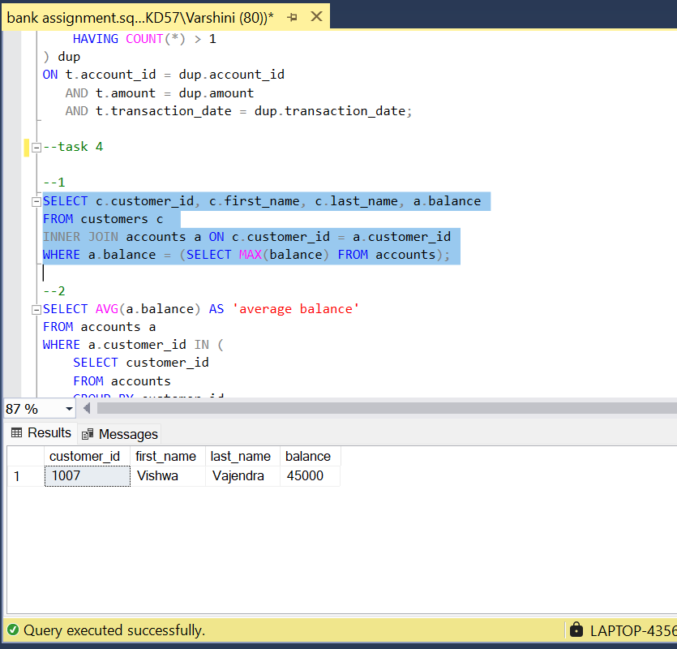

2) SELECT AVG(a.balance) AS 'average balance'

FROM accounts a

WHERE a.customer_id IN (

SELECT customer_id

FROM accounts

GROUP BY customer_id

HAVING COUNT(account_id) > 1

);

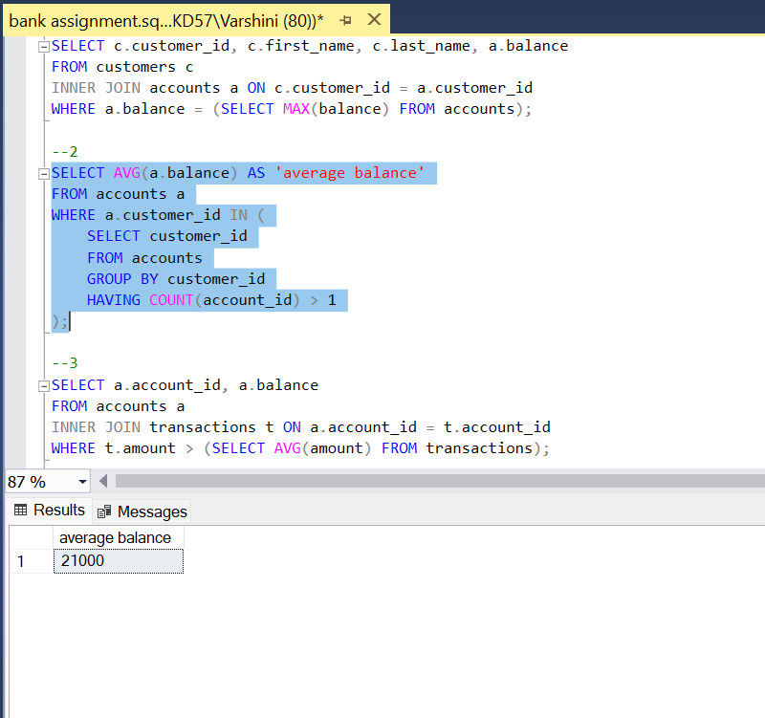

3) SELECT a.account_id, a.balance

FROM accounts a

INNER JOIN transactions t ON a.account_id = t.account_id

WHERE t.amount > (SELECT AVG(amount) FROM transactions);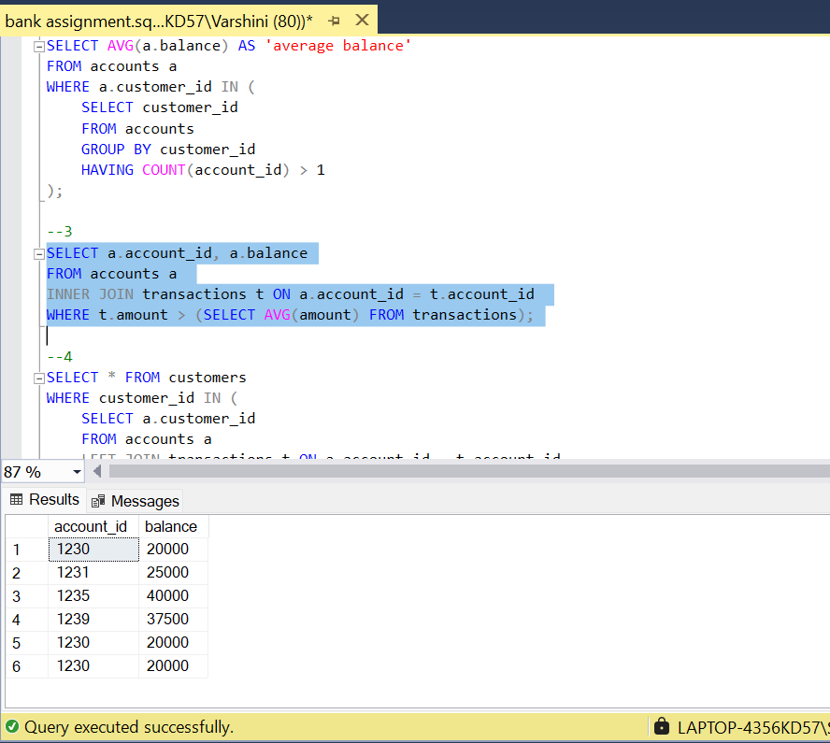

4) SELECT * FROM customers

WHERE customer_id IN (

SELECT a.customer_id

FROM accounts a

LEFT JOIN transactions t ON a.account_id = t.account_id

WHERE t.transaction_id IS NULL

););

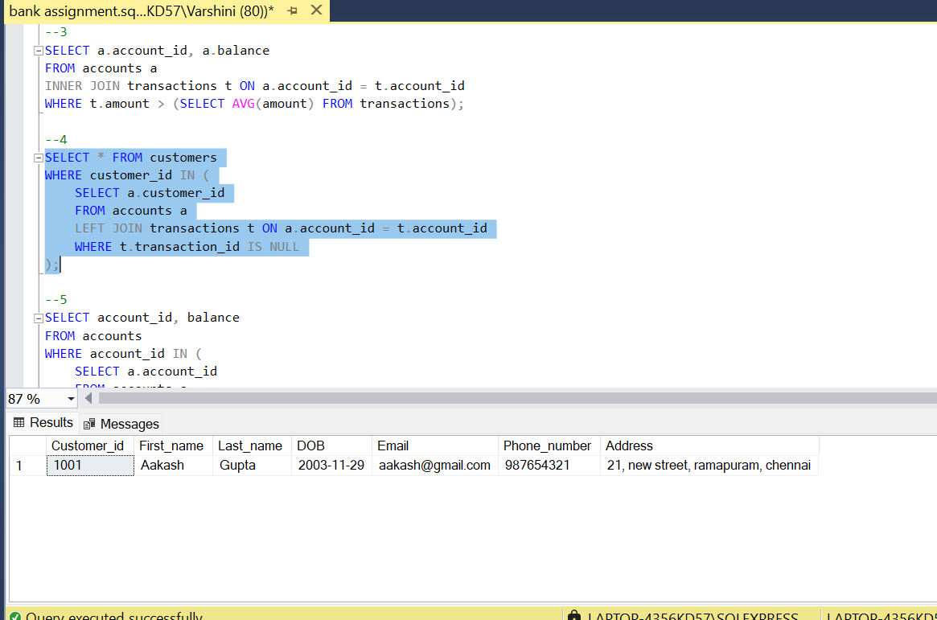

5) SELECT account_id, balance

FROM accounts

WHERE account_id IN (

SELECT a.account_id

FROM accounts a

LEFT JOIN transactions t ON a.account_id = t.account_id

WHERE t.transaction_id IS NULL

);

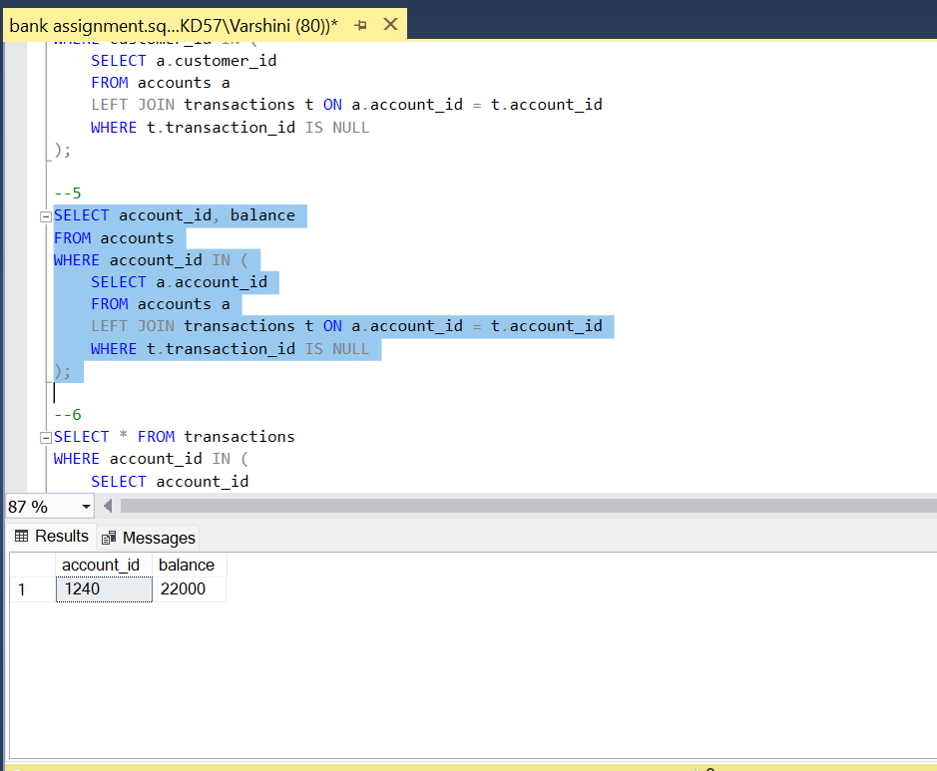

6) SELECT * FROM transactions

WHERE account_id IN (

SELECT account_id

FROM accounts

WHERE balance = (SELECT MIN(balance) FROM accounts)

);

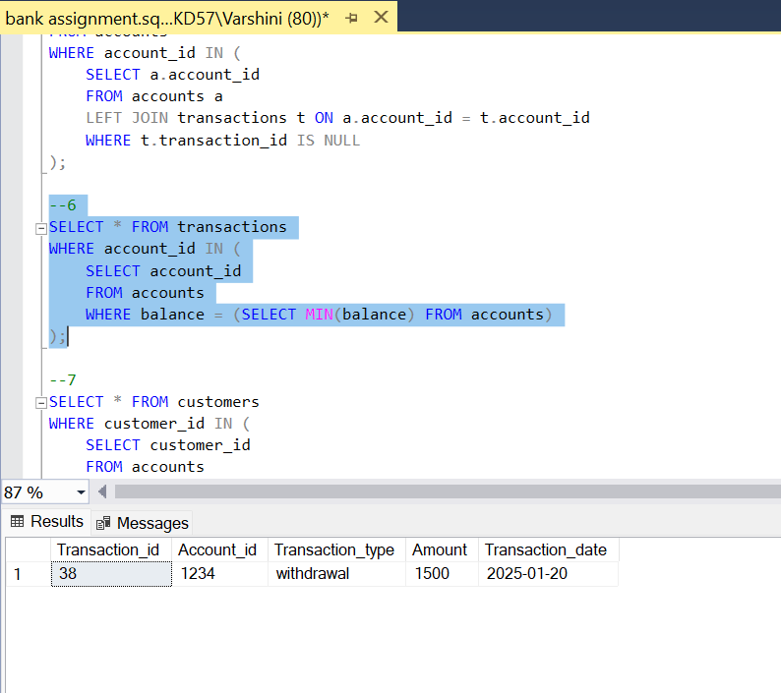

7) SELECT * FROM customers

WHERE customer_id IN (

SELECT customer_id

FROM accounts

GROUP BY customer_id

HAVING COUNT(DISTINCT account_type) > 1

);

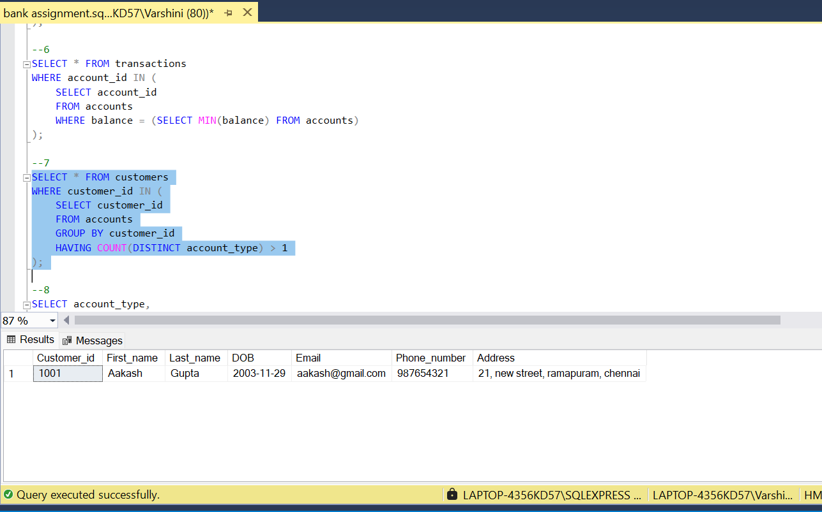

8) SELECT account_type,

COUNT(*) * 100.0 / (SELECT COUNT(*) FROM accounts) AS 'total_percentage'

FROM accounts GROUP BY account_type;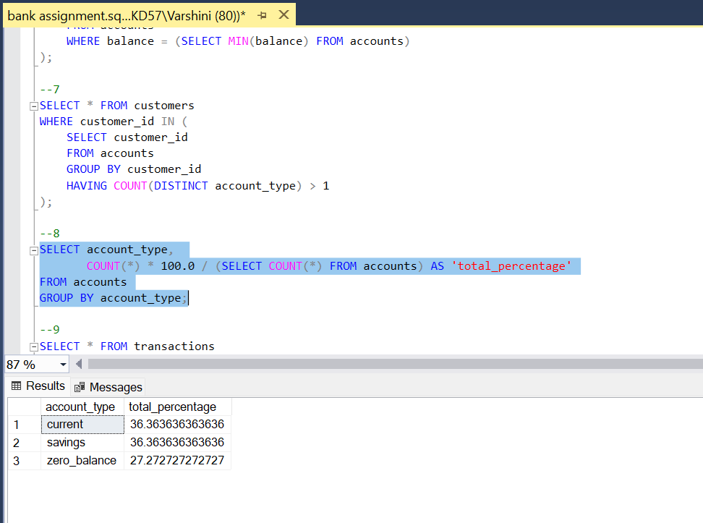

9) SELECT * FROM transactions

WHERE account_id IN (

SELECT account_id

FROM accounts

WHERE customer_id = 1002

);

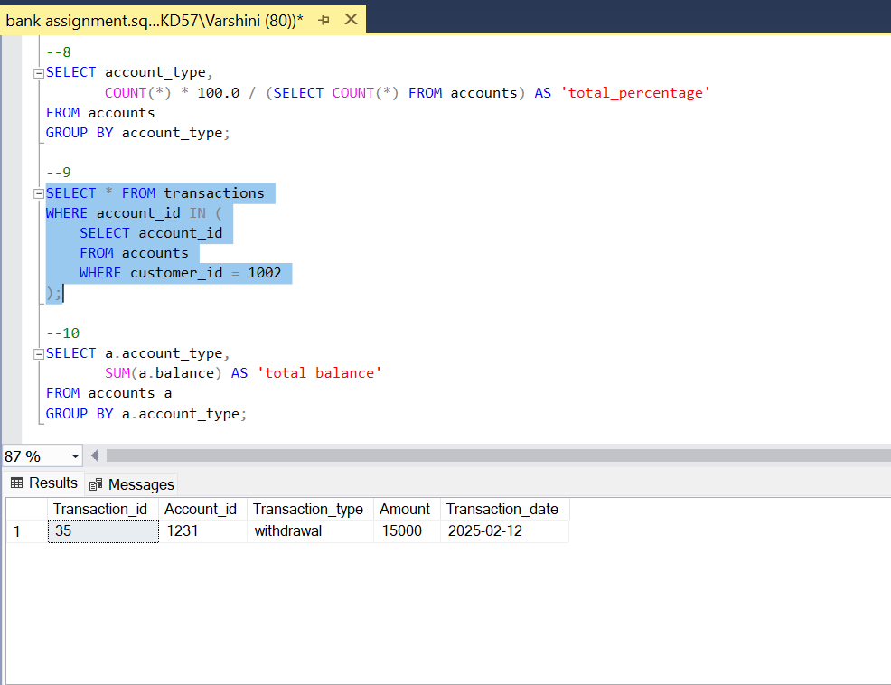

10) SELECT a.account_type,

SUM(a.balance) AS 'total balance'

FROM accounts a

GROUP BY a.account_type;

